EronSoft Development

http://www.eronsoft.com


Release: ESMonitor 1.2 © 1999 EronSoft
Date: April 11, 1999
Platform: Windows 95/98/or NT, 32-bit, Intel
Requirements: TCP/IP based network

Thank you for using ESMonitor. This document contains all the information you need to get started with this latest release from EronSoft.

ESMonitor is Y2K compliant and will continue to monitor your systems through midnight, December 31, 1999.

Contents:
Description
Installation
Usage
Troubleshooting
Support
Future Enhancements
Disclaimer

Description:

ESMonitor is an application that let’s you simply and easily monitor the status of network systems and services. ESMonitor has the capability to monitor systems using various protocols and tests. This includes: NT Services, PING, SMTP, HTTP, Telnet, and Windows share-based file access. Using per-system defined parameters you can customize ESMonitor to test different systems and services at periodic checkpoints and report an up or down incident via Internet e-mail. With the recent advances in paging, many of you already have page access via e-mail and this makes ESMonitor a great choice. In addition, periodic reports can be mailed (and/or posted to a web site) to managers and supervisors to keep everyone informed concerning the status of systems and services. ESMonitor also supports periodic “I’m working” pages to let you know that it is up and running and things are quiet because all is well. ESMonitor is very flexible in the way it allows you to describe each individual system or service and the handling of notification. If you want a simple, effective, and efficient method of monitoring your network services, ESMonitor is the product for you! To learn more, read on!

Every effort has been made to ensure the accuracy of this document. However, EronSoft makes not warranties with respect to this documentation and disclaim any implied warranties of merchantability and fitness for a particular purpose. EronSoft shall not be liable for any errors or for incidental or consequential damages in connection with the furnishing, performance, or use of this document or examples therein. The information in this document is subject to change without notice.

Installation:

First, you should have downloaded a package called ESMonitor10.zip. This package contains three files: Setup.exe, Setup.lst, ESMonitor.cab and ESMonitor.pdf. You are currently reading the file “ESMonitor.pdf”.

- Unzip the files into a temporary location such as c:\temp.
- Next, run the setup.exe program.
- The installation program should run through the process of copying files to the appropriate locations and adding a start menu group and icon.
- At the start of the installation program you may receive a message stating that certain files must be updated and your system must be restarted before continuing installation. If you receive this message, please allow it to restart and then re-run the setup.exe program.
- To launch the program simply select the “ESMonitor” application from the start menu.

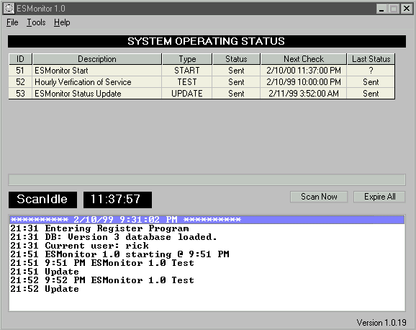
Technically, you’re all done. However, before ESMonitor can be used a few other steps must be performed to ensure that everything will work for you. Move on to the usage section to get things up and running for your organization.

Usage:

When ESMonitor loads for the first time it will present the “System options” screen. Several questions must be answered to ensure correct operation. Below you will find each of the setup dialogs necessary to use ESMonitor. Each section has been clearly marked for quick reference later but is presented in order of expected need.

System Options:

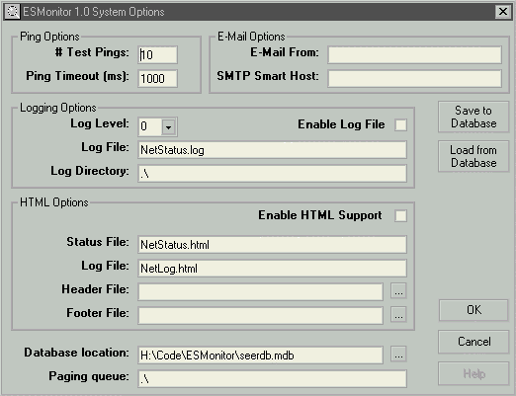Ping Options:

# Test Pings: this is the number of pings that will be sent to a system that is being tested via PING. Failure to respond within this number of pings will result in ESMonitor marking the system as down.
Ping Timeout (ms): the number of milliseconds that ESMonitor will wait for the return of a single PING.

E-Mail Options:

E-Mail From: specifies the name that ESMonitor will use when sending mail – should be a fully qualified name in the form of user@domain.
SMTP Smart Host: the sendmail system to use when sending mail. Must be specified and should contain a valid IP or resolvable hostname of a system which is listening on port 25 for standard SMTP mail.

Logging Options:

Log Level: specifies the level of detail to include when creating log files. A larger value will provide more details but will also decrease performance and create large files.
Log File: path to file for logging.
Log Directory: directory to place logs for individual.
Enable Log File: determines if logging is on or off.

HTML Options:

Status file: name of file to be created/updated with the current status of systems. ESMonitor will periodically update this file. It should be placed in a location that is being served by IIS, Apache, etc.
Log file: name of the file to be created/updated with the current log. This is the information that appears on the bottom half of the ESMonitor main window.
Header file: file to be prefixed when creating the status or log HTML files. This lets you give the output from ESMonitor the look and feel of your organization.
Footer file: file to be appended to the status and log files.
Enable HTML support: determines if the status and log html files are written.

General:

Database location: MS Access database being used by ESMonitor. You can either perform database updates from within ESMonitor or directly from Microsoft Access. You can either enter the path or use the “…” button to browse for a database.

Paging Queue: location to place page files. The paging queue manager then processes these files. A companion product is available which will process these files to communicate with alphanumeric paging systems via modem. The next version of ESMonitor will contain this support internally.

Save to database: depressing the button will take all the information contained in this dialog and insert it into the ESMonitor database for later retrieval. This is especially useful if you are attempting to move ESMonitor from one system to another.

Load from database: loads all options from the specified database.

OK: saves your changes and returns to the main screen.
Cancel: cancels your changes and returns to the main screen.

Modify Personnel Database

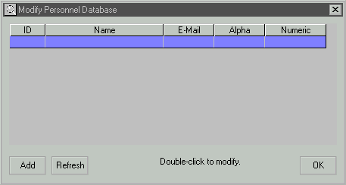
The next thing you will probably want to do is choose the “Tools”, “Modify Personnel Database” option. First you are presented with a list of all currently defined users and an indication if this user is setup for notification via e-mail, alpha paging, or numeric paging.

To add a new user to the database simply click the “Add” button.

To edit a user simply double-click on the name in the list.

When you are finished making changes click the “OK” button to return to the main ESMonitor screen.

After pressing the “Add” button you will be presented with a new dialog. A similar screen is presented in the case of edit except the corresponding fields have been filled from the database with their current values.

Person’s Name: name you wish to appear in all other references to this person.

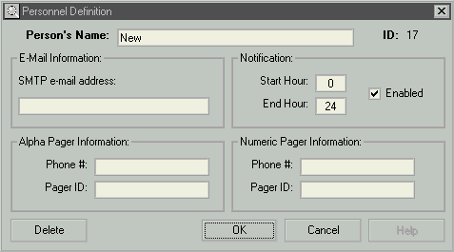
SMTP E-mail address: this individual’s e-mail address. It should be specified in the form of user@host and should be available via the smart host you specified in the system options screen.

Notification, start hour: This is the hour when this user should start getting notifications. If you wish to specify “shifts” for users or there may be individuals who wish to get notifications but perhaps not at 3AM. Of course, setting a start hour also requires you to specify an end-hour.
Notification, enabled: controls if the notification hours are currently in use.

Alpha Pager information: This feature is not available in your version of ESMonitor.

Numeric Pager information: This feature is not available in your version of ESMonitor.

When you have finished making changes simply press the “OK” button to commit your changes to the database. Pressing “Cancel” will return to the “Modify Personnel” screen but will NOT save your changes. Pressing “Delete” will delete the current person from the database.

Modify Notification Database

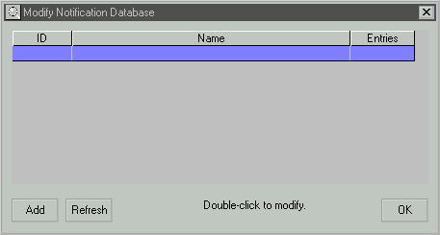
Next, you need to setup notifications for users. Notifications are designed to allow “groups” to be created. When ESMonitor detects a system changing state it will notify all users in a particular group. This will allow you to create groups such as “E-Mail admin.”, “Webmasters”, or “IS Support”. Okay, let’s setup your notifications: choose “Tools”, “Modify Notification Database”.

Notification Definition:

This dialog works basically the same as the personnel dialog so I won’t go into details here. Once you choose to edit or add a notification you are presented with this dialog:

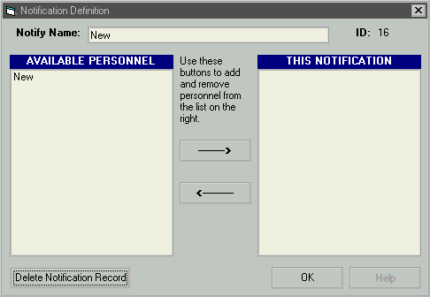
Notify Name: this is the name you want to use to identify this notification group. This name will appear in the list of available notification entities when setting up a system.

Available personnel / This notification: to add a user to the group simply click on the user’s name and then on the “right-arrow”. To remove a user from the group click on the user’s name and click on the “left-arrow”. The list of users appearing in the list on the right will be notified when this notification group is triggered.

If you wish to delete this notification group altogether, simply click on the “Delete” button. When you are finished making changes simply click on the “OK” button to return to the “Modify Notification Database” screen.
Modify System Database

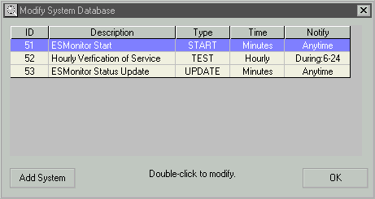
Finally, let’s do the real stuff. Of course since you have spent all this time setting up your personnel and notification database you would probably like to specify exactly what you want ESMonitor to monitor. I expect that you will return to this dialog often while getting things like you really want them.

As with personnel and notification, you are first presented with a dialog listing all available systems and giving you the ability to add new ones or edit existing ones.

To add a new system simply click the “Add system” button or to edit an existing system simply double-click on the system’s name (or anywhere on that row).

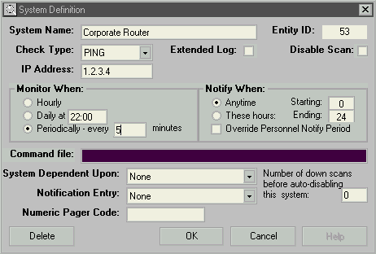
Okay, now let’s setup our system or service:

System Name: name you wish to appear on the main ESMonitor grid, e-mail messages, and log files.

Check Type: select the type of system or service from the list: PING – ESMonitor will send icmp ping(s) to the system a report status based on the ping response, HTTP – ESMonitor will attempt to establish a web connection to the address, SMTP – ESMonitor will open a connection to port 25 (SMTP) and negotiate a standard SMTP HELO conversation, FILE – specifies the UNC path to a file which should be monitored for availability, TEST – periodically triggers this event to allow users to receive “test” messages to ensure that ESMonitor is alive and operating, UPDATE – specifies that ESMonitor should periodically send an e-mail containing all status information to a group of users, START – a notification that will be performed when ESMonitor starts or every year, TELNET – triggers ESMonitor to open a connection to port 23 and negotiate a telnet connection and report status, SERVICE – ESMonitor will periodically check the status of an NT service and report running or stopped conditions. The service should be specified using the format “\\machine\service name”.

Extended Log: specifies that this item should have a file created to monitor up/down events. This makes it easy to generate uptime statistics for a particular system or service.

Disable Scan: allows you to temporarily remove an item from the scanning queue.

IP Address / URL/ UNC path / Service: depending upon the type you specified for the “Check Type” this field will allow you to enter the appropriate IP address, URL, service, or file.

Monitor When: HOURLY – ESMonitor will check the status of this item each hour, DAILY – will check the status at the specified time each day, PERIODICALLY – will monitor this system or service every [N] minutes. For example, specifying 120 would check a system every 2 hours.

Notify When: ANYTIME – just like it sounds, ESMonitor will generate a notification anytime day or night, THESE HOURS – will only generate notify events between the specified start and end hours, please use 24 hour format. Choosing “Override Personnel Notify Period” will cause ESMonitor to ignore the notification hours specified for a given individual if they are specified. You would probably want to use this option if the monitored system was very critical, such as a main router or primary web server.
System Dependent Upon: this is one of the more advanced features of ESMonitor. You can make any system dependent upon another system. Suppose for example that your monitoring system is connected to a smart hub which is then connected to a router, which is then connected to your Corporate Internet router, which is then connected to your ISP’s router which is then connected to the Internet. Suppose you added a system to monitor the status of your ISP’s router but the hub was the system which was currently at fault. In our example you would add a system for each of the dependent parts of the route and make then dependent in the order in which they are traversed. The Internet would be dependent upon the ISP router. The ISP router would specify the Corporate Internet Router as a dependency. The CIP would specify the hub as a dependency. If ESMonitor detected that the hub was not responding it would trigger a notification event for the hub but not for each affected system. The Internet is probably up but you are unable to reach it because of the hub problem. Once the hub is available ESMonitor will work through the tree to determine the status of all previously unavailable components and make notifications as appropriate.

Notification Entry: When a notification is triggered, either by a system changing state or via a TEST or UPDATE event, ESMonitor looks up the notification group to determine which users should be informed. Simply select the appropriate group from the pull-down. If you wish to modify the available entries see the section “Modify Notification Database” previously discussed.

An added feature is “number of down scans before auto-disabling this system”. It’s a long title but that says it all. Suppose you are monitoring a device which is expected to become unavailable or consumes a large amount of resources to monitor. In the event the system becomes unavailable or “down” for a specified number of intervals, it will be automatically disabled from future scans. To re-enable the item simply return to this screen and remove the check from “Disable scan”.

When you are finished making changes click “OK” to return to the system list.

Troubleshooting:

Below are a few tips and suggestions to get the most out of ESMonitor. Some of the most common errors are listed to help correct your problems before things get frustrating.

- Make sure you have specified a valid SMTP smart host. ESMonitor will be unable to deliver e-mail notification messages without a valid smart host.
- Specify all test addresses using IP addresses – not textual host names. This will increase the speed and also allow ESMonitor to check devices without using a nameserver to lookup the IP of the device. This could pose an additional problem in the event of an in-operational or inaccessible nameserver.
- Make sure the system you are running ESMonitor on has the latest Winsock stack. Some stacks may not support the low-level ICMP protocols and not allow ESMonitor to perform a ping.
- If you are having problems with the database, try opening it in Microsoft Access. You can also use Access to perform a compaction or rebuild if your database manages to get damaged.
- Make sure your PC clock is accurate.
- ESMonitor is year 2000 compliant. It WILL continue to function correctly through midnight, December 31, 1999. The main screen will display years such as “00” but is internally storing “2000”. The next version will feature full dates in the onscreen display.
- Watch the ping timeouts and counts. If you are attempting to monitor devices across WAN links using ISDN or frame relay, initial packets may be dropped and some situations could require increasing this value. ESMonitor will not continue sending pings in the event at least one ping is returned successfully.

Support:

This product is currently supported via e-mail only. Please e-mail all questions to support@EronSoft.com.

Future Enhancements:

When you license ESMonitor you will be automatically added to a mailing list and will be informed of new updates as soon as they are available. Look for these exciting new features:

• Direct access to alpha-numeric and numeric pages via modem interface
• Graphical display of network status
• Additional test support including: touch, SQL, user defined ports, and command-line tests
• Notification via command files

Limitations and Disclaimer:

This software is being licensed to you solely for the purpose of monitoring the systems and services at a single site. You may not sell, distribute, or commercially exploit this software. You may not reverse engineer or decompile the software. Your use of EronSoft Development’s ESMonitor product in accordance with this license is void of further licensing fees unless otherwise stated in the instructions. Any use of the software contained in the “ESMonitor10.zip” distribution is on an "AS IS" basis. ERONSOFT DEVELOPMENT (THE "LICENSOR") EXPRESSLY DISCLAIM ALL WARRANTIES, WRITTEN OR ORAL, EXPRESS OR IMPLIED, INCLUDING WITHOUT LIMITATION, WARRANTIES OF MERCHANTABILITY OR WARRANTIES OF FITNESS FOR A PARTICULAR PURPOSE. THE LICENSOR SHALL NOT BE LIABLE FOR LOSS OF PROFITS, LOSS OF USE, OR INCIDENTAL, CONSEQUENTIAL, OR SPECIAL DAMAGES THAT RESULT FROM USE OF THIS SOFTWARE OR OUTPUT FROM THIS SOFTWARE, EVEN IF MADE EXPRESSLY AWARE OF THE POSSIBILITY THEREOF. THE LIABILITY OF THE LICENSOR SHALL NEVER EXCEED THE DOLLAR AMOUNT THAT YOU PAID TO THE LICENSOR FOR THE USE OF THE SOFTWARE DURING THE 12 MONTHS PRIOR TO THE DATE OF A CLAIM. Any rights not expressly granted in this license are reserved to the Licensor.

Licensee agrees to indemnify and hold EronSoft harmless from any claims or damages made against EronSoft as a result of misrepresentation or omission on the part of Licensee or representatives of Licensee. Licensee shall be solely responsible for any claims, warranties or representations made by Licensee or Licensee’s employees or agents.

Use of the ESMonitor product constitutes agreement with these limitations and disclaimers.

